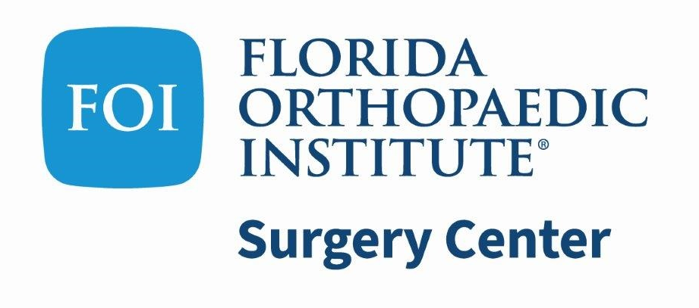

PATIENT AUTHORIZATION TO DISCLOSE HEALTH INFORMATION
In order to receive copies of your medical records, you are required to fill out a complete Patient Authorization to Disclose Health Information. Filling out an incomplete form will delay in obtaining records. Medical records will be processed within 10 business days from the date this form was signed and received. Holidays and weekends are excluded.

Please choose delivery method below:
□Mail to: □Myself □Individual/ Organization □Pick up: Call when records are ready
Return form to: Florida Orthopaedic Institute Surgery Center, 5901 E Fowler Ave ; Suite 200 Temple Terrace, FL 33617

Please print all information and sign where indicated below
Patient Name: ______________________________________________________________________________
Address: ___________________________________________________________________________________
City: __________________________________ State: _________________ ZIP:_______________
Phone Number: _____________________________ Email: ________________________________________

I hereby consent to the release and disclosure of my personal health information to:
(Please print the complete facility name, individual and address. Any missing information may cause a delay in obtaining the records)
Name (Individual or Organization):_______________________________________________________________
Address: ___________________________________________________________________________________
City: __________________________________ State: _________________ ZIP:_______________
Phone Number: _______________________________ Fax: ________________________________________

▬▬▬▬▬▬▬▬▬▬▬▬▬▬▬▬▬▬▬▬▬▬▬▬▬▬▬▬▬▬▬▬▬▬▬▬▬▬▬▬▬▬▬▬▬▬▬▬▬▬▬▬▬▬▬▬▬▬▬▬
For the Following Purpose(s):
____ Continuing Medical Care ____ Personal Use
____ Information for Insurance Co. ____ Information for Attorney
____ Other (please specify)_________________________________________________

This authorization for release includes my personal health information consisting of:
_____ Operative Reports : (Please specify date of service) _________________________________________
_____ Discharge Summary
_____ Other (please specify) ________________________________________________________________

▬▬▬▬▬▬▬▬▬▬▬▬▬▬▬▬▬▬▬▬▬▬▬▬▬▬▬▬▬▬▬▬▬▬▬▬▬▬▬▬▬▬▬▬▬▬▬▬▬▬▬▬▬▬▬▬▬▬▬▬
*********For questions, please contact (813) 972-4905, or Email - FOISCMEDICALRECORDS@USPI.COM
I understand that the information outlined in this release will be disclosed according to the instructions of this release within ten (10) business days of Florida Orthopaedic Institute Surgery Center’s having received this release authorization. I understand that I am free to revoke this release authorization at any time by notifying the practice in writing. I also understand that the information disclosed under this release is subject to re-disclosure and no longer protected by the Privacy Regulations (45 C.F.R. 164).
** This authorization expires one year from the date of this request.
** This authorization is NOT valid if not filled out completely or not signed
** Florida Orthopaedic Institute Surgery Center may elect to charge the individual/organization listed above.

Patient Signature:________________________________________________ Date:_________________
DOB:________________________ SSN:__________________________
▬▬▬▬▬▬▬▬▬▬▬▬▬▬▬▬▬▬▬▬▬▬▬▬▬▬▬▬▬▬▬▬▬▬▬▬▬▬▬▬▬▬▬▬▬▬▬▬▬▬▬▬▬▬▬▬▬▬▬▬
FOR OFFICE USE ONLY:
□ REVOCATION DATE:
letter/document must be attached.
MR#_____________________________
Document flow: Patient’s Medical Record / Revised: 03/18/2025

